Angeles University Foundation  
College of Computer Studies

Criminal Record Management System

BSCS3

By

Mica Cortez  
Natasha Purvis  
Gabriel Santos

Dr. Rosanna A. Esquivel

December 29, 2021

Table of Contents

1. Statement of the Project 2

1.1 Summary: 2

1.2 Developement 3

2. Software Development Model 3

2.1 User stories: 3

2.2 Use Case: 3

2.3 DFD 3

2.4 Architectual Design 5

3. Prototype 5

4. Conclusion 7

5. Sources 7

1. Statement of the Project

1.1 Summary:

An application that keeps track of the criminal history for users. Ideally for police officers to have an easier access to criminal data. This makes it for law enforcement to understand quickly who they are dealing with as they get a hold of someone and put them into custody. This benefits the processing as it can be forwarded to headquarters and make the transition from the arrest site to the jail cell much faster.

## 1.2 Development

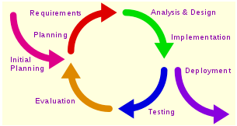

Because there’s room for updating and connected features, the iterative method is the best method to be used when completing this application. With an attentive team the different elements can be acknowledged and prepared to fit the goal of the application.

1. Software Development Model

2.1 User stories:

As a police officer I want to verify the assailant has a criminal record so I can be aware of any criminal history they may have.

As a police officer I want to input changes into the application so I can make sure future users are aware of this criminal’s history.

As a police officer I want to input my credentials so I can sign into the application.

As an administrator I want to verify info inputted about a criminal so I can update the database.

As an administrator I want to input my credentials so I can authenticate new application users.

2.2 Use Case:

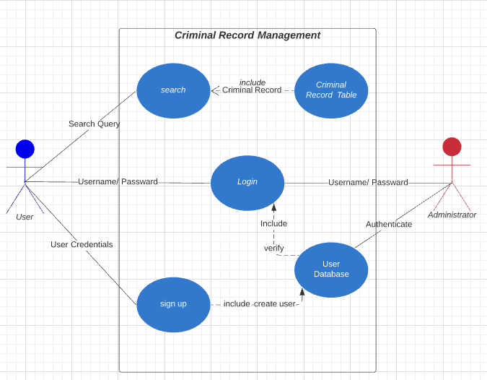

## 2.3 DFD

The students when making this software provided two different data flow charts, one for the criminal record management and the other to show basic user flow.

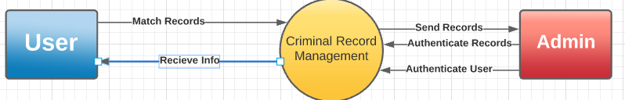

this is for the data diagram level 0  
On this diagram, there are 2 entities namely: User and Admin and have 1 process namely: Criminal Records Management, it simply shows the user inputs match records into the Criminal Record Management System and outputs the information to the user, whereas The System will update the records that will be given to the admin. Then the Admin will provide security to the records in the system.

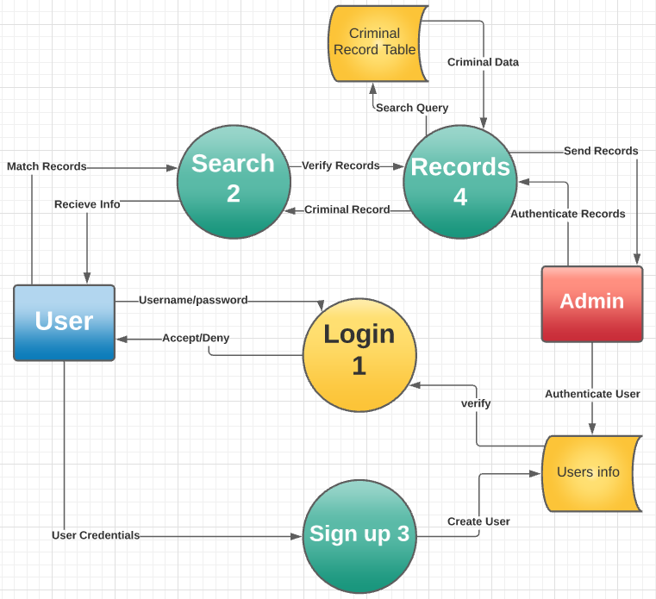

In this diagram, we expand the explanation of the data diagram level 0 above. But still there are 2 Entities and we just pop the system into various parts. We have the search, log, and sign up. in the User entity can search for query, Input the username and password, and input for User Credentials. In the search process, we can input Prime data into the criminal record in return we can search for the updated data of the records added that will be able to accessed by the admin to update the data from the table. Next the Login process, in this stage, the user inputted the username and password then it enters the user table that will verify what was inputted by the user. Then the last is the Signup process, this is intended to unaccustomed users that needs to sign up and put their records so that the admin will save all the documents and details of the user.

## 2.4 Architectual Design

Another diagram, the architectural design they have provided shows a simplistic and direct correlation of what each section of the application is expected to do. As you can see already, in just the few bits of going into the description of the application and thorough and thought-out design process is needed to assure a successful product.

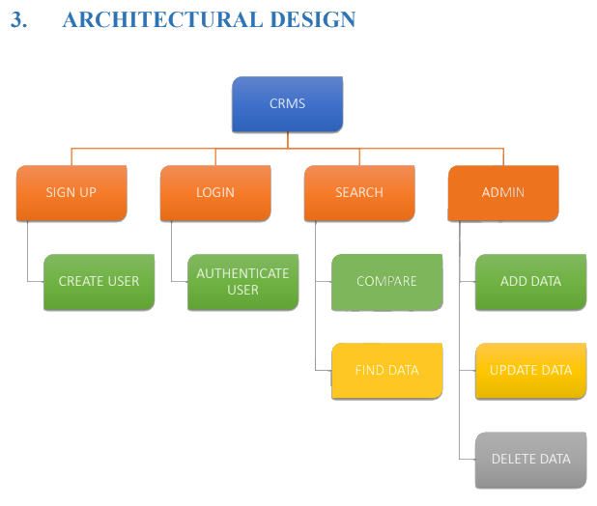

# Prototype

The students go into further detail about their team scheduling with a gantt chart to keep the team organized and focused. And provide a risk analysis as, not one product is ever perfect, in the case of their software they have addressed potential registration, storage and credential compromise.

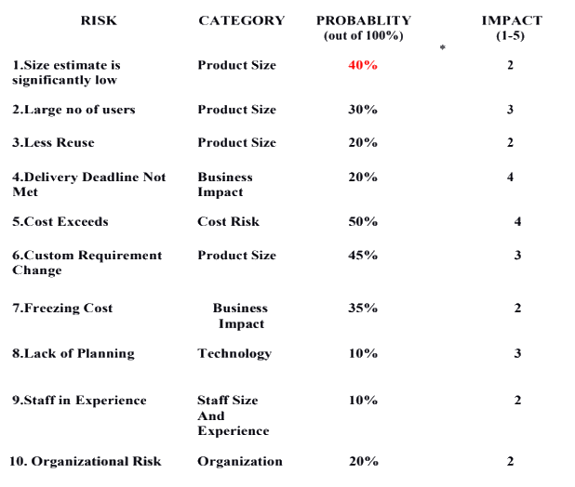

After detailed description of how the application works and potential risks the code was provided by the students give the result of the user interface that has been provided in the pictures below and a user manual as all software's should be provided with a user manual.

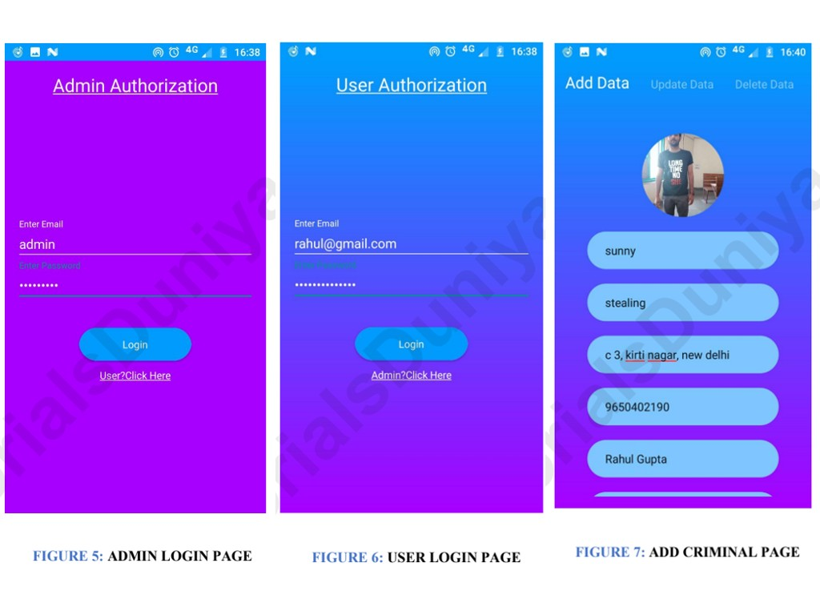

# Conclusion

As shown in these three examples, software engineering is not an easy feat. It takes coordination, focus, and drive. All the designs provided a thorough report of how their design was to be executed and used. No corners were cut as in a more professional setting, time is money and energy.

# Sources

Gupta, R. Gupta, S. Ray, R. Garg, T. Criminal Record Management System. <https://drive.google.com/file/d/1wumxtm5POexbi3ottedmDvLeXsM4uVy6/view>

Rana, K. (2021, July 1). *Data flow diagram: Examples, symbols and levels*. ArtOfTesting. Retrieved December 29, 2021, from <https://artoftesting.com/data-flow-diagrams-dfd>

N/A, N. A. (n.d.). *Software engineering - quick guide*. Tutorialspoint Simply Learning. Retrieved January 2, 2022, from <https://www.tutorialspoint.com/software_engineering/software_engineering_quick_guide.htm>